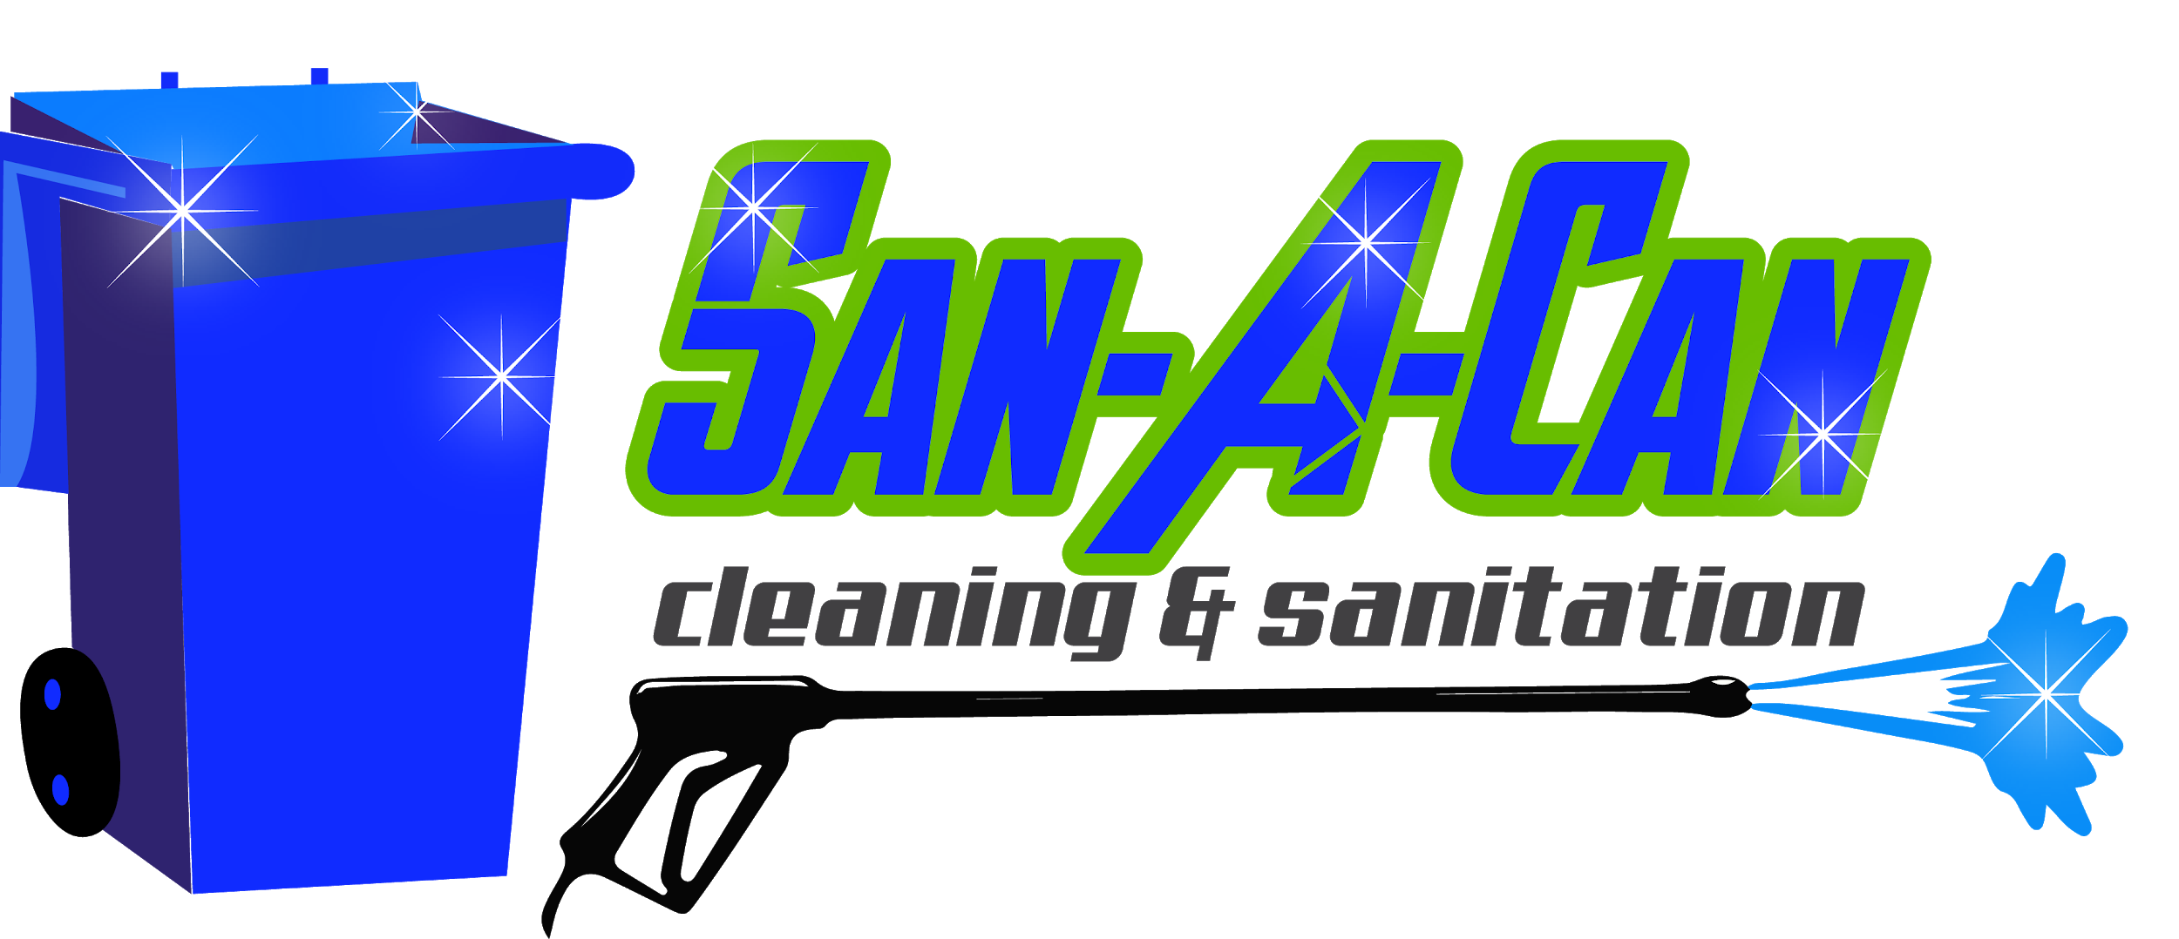

NOTICE OF SERVICE CHANGES

To our valued customers,

We need to make you all aware of important changes to our regular service this year and into the future. These changes were necessary to be able to provide the best customer experience possible for all our customers. Please read through the entire message so that you are aware and prepared for service this year.

List of service changes:

- Next Day Service – This year we are scheduling cleanings for the day after regular waste pickup. To clarify we will be running service Tuesday-Saturday each week. So, if your trash pickup is Monday, your cleaning will be on Tuesday and the same goes for each cleaning day of the week through Saturday. Note: Cleanings on holiday weeks will still be the day after your trash pickup day. For example, if the holiday is on Friday, your cleaning would be on Sunday, since waste pickup would then be on Saturday.

- We know this change may be an inconvenience at first, but it is necessary to provide timely service for all customers. This change was made due to inconsistent or late trash/recycling pickup times throughout different areas. This resulted in our customers receiving late service or due to low light conditions in the evenings, they had to be rescheduled. This change ensures cleanings to be completed on the scheduled day of service by sundown and for most customers before 5pm. Cleaning days will still run from sunup to sundown.

- Also, we realize that this change will conflict with some customers village or HOA rules. We are communicating with all cities we service to make them aware of the change and that we require the cans to be out one day after trash pickup. Most cities allow cans to be out until 6pm the following day. We will also be making efforts to contact all known HOAs to make them aware. If you have concerns, we would be more than happy to contact any HOA or village on your behalf, if provided with the correct contact person’s information. We thank you in advance for your understanding and patience through this transitional period.

- Cans must be visible from the street. While we prefer the cans to be left at the curb, we understand if you must bring them up to the house for any reason. As long as they are accessible and visible from the street our technicians will place them back where they found them after cleaning. Please leave all cans to be cleaned out! If you have cans that are not scheduled to be cleaned, put them away. You will be charged for the number of cans you signed up for even if one or more are not out at time of service. Thank you in advance!

- Top-of-Drive Service – After cleanings are performed, all cans cleaned will be brought to the top of the driveway to make customers aware service has been completed and as an added perk to regular service. To get the most out of this added feature, leave the cans at the curb after trash pickup. Let us bring them back up for you after cleaning!

- Please note, this feature applies to driveways that are 100 feet or less. If your driveway exceeds 100 feet, cans will be left at the curb. For liability reasons we cannot drive our trucks onto any driveway.

- Awareness of Service Interruptions – While we try to communicate with all affected customers directly, we cannot always reach everyone. So, all service interruptions due to weather or any other unforeseen reason will be updated on Facebook. Please be sure to like and follow us on Facebook for these updates. We will correspond through email or phone to reschedule the missed cleaning.

- Temperature Based Service – Due to high call volume during the mild winter, we will now be running service year-round but will be based on temperatures and outside conditions. At our discretion, if temperature allows and streets are clear, we will be running service. Regular service interruptions will be posted on Facebook. If you are not on social media and have any questions about your service, feel free to give our office a call.

- Text Reminders – We started this service last year and it will continue but we will be contacting each customer for a mobile number if we do not have one on file already. Please if you notice that you receive an email reminder but not text or vice versa, call our office to update contact info. (844) 726-2226

We want to thank you in advance for taking the time to read through this email thoroughly. While we stride to provide the best customer experience possible, we could not do it without the continued support and referrals of our great customers. Please feel free to contact our office by phone or email with questions or concerns. We are looking forward to a great 2020 season! Be on the lookout for service reminders. See you soon!

Highest Regards,
The San-A-Can Team

